**Format for uploading details in Github and Slack in word file format**

**(Fill this format(docx) daily and upload it in both Github and Slack)**

**Student Name : SURYA PRAKASH S**

**Class and Sec : VI B**

**USN : 4AL17CS101**

|  |  |  |  |  |
| --- | --- | --- | --- | --- |
| **Online Test Details** | | | | |
| **Subject** | **-** | | | |
| **Semester** | **VI -B** | | **Duration** | **-** |
| **% of marks** | | **-** | | |

**Encl : snapshot of the test result**

|  |  |  |  |
| --- | --- | --- | --- |
| **Certification Course Details** | | | |
| **Course** | **Programming in Java**  **Data Structures** | | |
| **Certificate Provider** | **-** | **Duration** | **04 hours** |

**Encl : snapshots of the daily class acitivities (atleast two snap shots)**

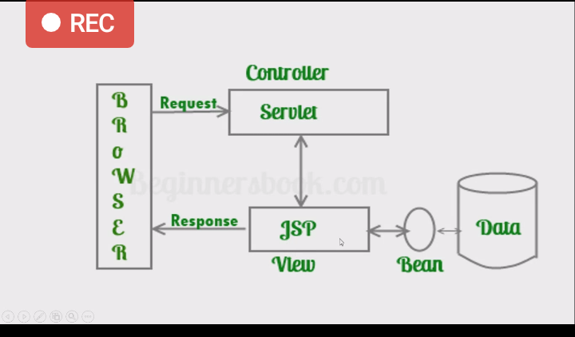

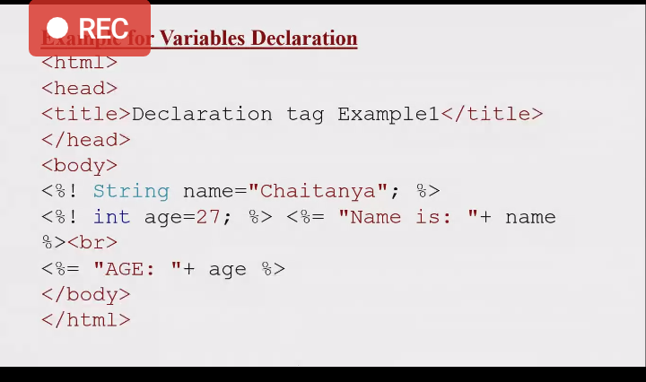

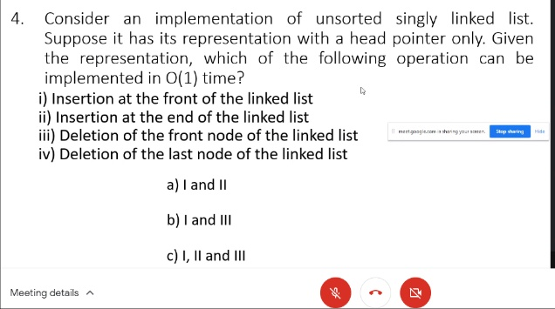

|  |  |
| --- | --- |
| **Coding Challenges** | |
| | **Problem Statement: 1. Python Program to Read a File and Capitalize the First Letter of Every Word in the File 2. C program to implement Sort stack using temporary stack 3. C program to implement simple queue using SLL 4. C program to implement circular queue using SLL 5. C program to implement multiple stack operation using SLL 6. C program to implement operations on multiple queue.** | | --- | | |
| **Status: Completed** | |
| **Uploaded the report both in Github & Slack** | **Yes** |

**Encl : snapshots of your response to challenge.**

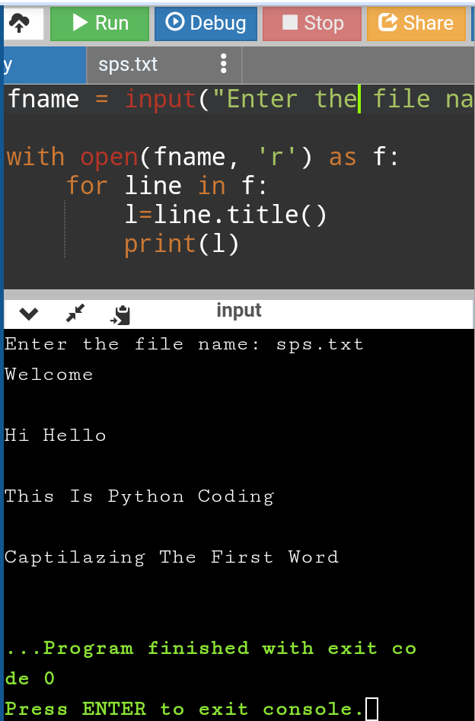

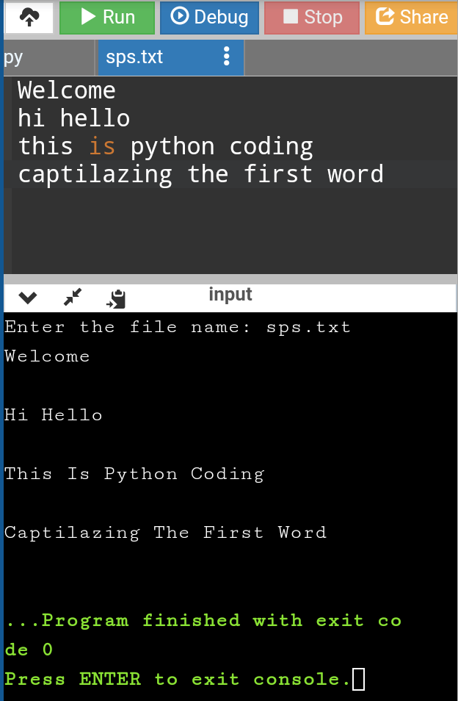

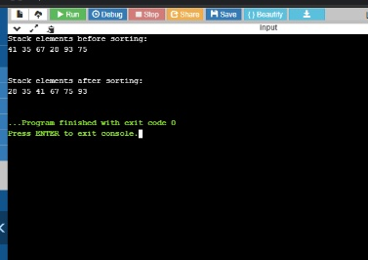

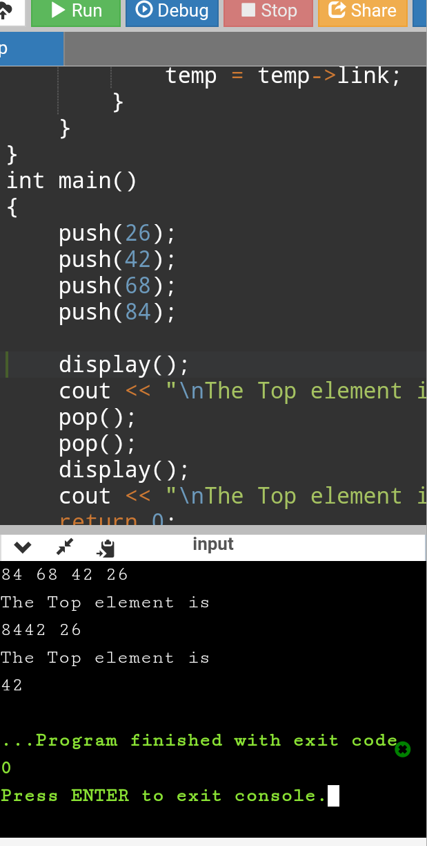

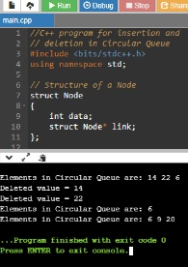

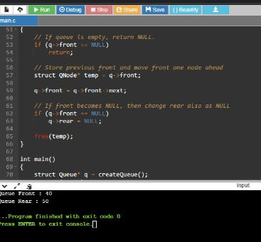

https://github.com/SPSSURYA/Online-Coding-And-Certification-Course